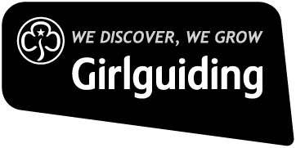
Risk Assessment Form
Event/Activity: Backwoods cooking
Event Coordinator: |  |  |  | Numbers  Attending: |  | Adults: |  |  | Children:
Consent for Event/Activity forms completed: (circle)  Yes No N/A |  |  | Venue:  Guys farm activity centre |  |  |  |  | Instructor qualifications checked*  Yes No  (if applicable) :
Hazard | Who is affected? | What controls  are in place? |  |  | Risk level  (L/M/H) |  | Are further controls necessary? |  |  | Action by  & date | Review by  & date
Backwoods Cooking  Fire safety equipment to be used  Aware of naked flames  Control measures to be used  Choking from smoke  Slips, trips, falls  Burns, grazes, blisters  Cuts from knives  Food poisoning from poorly cooked food. | All participants | Equipment is checked by organiser and instructor  Girls to be aware of fire safety always.  Hair to be tied back.  Use of equipment  Leaders to supervise.  Use of fire safety equipment  Poor weather conditions -check on day.  Check food safety/Equipment handling  Hand Hygiene  Injuries-to know where first aid is-check for, Burns, slips and falls.  Clean Water available/First aid kit available  Rubbish to be disposed of safely. Fire to be dampened and checked is not still live. Food waste to be put into sealed bins.  Hot coals/wood to be cold before disposal in appropriate container-see onsite regs |  |  | L  L  l/m  m  l/m |  | All participants to be aware of potential hazards. This activity must always be supervised .  No overcrowding of activity |  |  | Ongoing throughout the event

