GUYS FARM
30th
ANNIVERSARY CHALLENGE
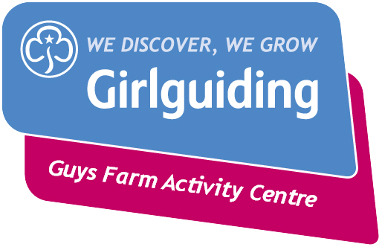
Elaine Clare

WELCOME TO THE GUYS FARM 30th ANNIVERSARY CHALLENGE
PEARL ANNIVERSARY
October 2017

Celebrating 30 years of Guys Farm Activity Centre

Let’s begin with the history of Guy’s Farm:
The site of Guys Farm lies in the Parish of Ellel, a few miles south of Lancaster. (The area used to be known as Nan’s Nook)
The buildings of Guys Farm do little to indicate the history of the site, although there are 2 date stones used as lintels on the BARN. (Can you find these on your next visit?)
In May 1984 Lancashire West Girl Guides became interested in the site of Guys Farm for use as a County Outdoor Activity Centre. Mrs Elsie Cardwell, Mrs Audrey M Forster (County Commissioner) and Mrs Patricia Jackson (County Camp Adviser) acted on behalf of The Girl Guide Association and bought the site for £76,000.
Guys Farm had an official opening in October 1987, which was attended by members of Girl Guiding in an official opening ceremony. Brownies, Guides and Leaders alike enjoyed the day.
There are many areas within Guys Farm for members to enjoy, the Orchard, which used to have an abundance of apple trees, Top and Bottom meadow for camps, both small and large, Waterside, down next to the lake incorporating a chapel (place of worship.) There are 3 buildings in which to enjoy an indoor holiday, the Barn (actually and old converted barn) The House and the Piggery, which is said to be on the site of the old pig pen.
When Guys Farm first opened no coaches were allowed down the lane. Guides and other members had to carry ALL their camping equipment down the long lane and on to their campsite, sometimes making several trips. (There were a lot of moany Guides in those days)
There have been many changes and improvements to Guys Farm in the last 30 years, updated camping sites with electricity and hard standing, flushable outdoor toilets, climbing tower, archery setup, abseiling, pizza oven, assault courses and modern comfortable indoor accommodation. There is even a shop where you can pick up a souvenir of your time at Guys Farm, from badges to hoodies, pens to notebooks.
Rainbows, Brownies, Guides, Senior Section, leaders and Trefoil Guild members enjoy the facilities that Guys Farm has to offer now and for many years into the future.

Information from “A History of Guys Farm” written by Julia M. Beeden (Thankyou to Elaine Clare for lending us this book)
TO COMPLETE THIS CHALLENGE EACH SECTION SHOULD COMPLETE:

- RAINBOWS – One from each section, plus 3 of your own choice

- BROWNIES – One from each section, plus 5 of your own choice.

- GUIDES – One from each section, plus 7 of your own choice

- SENIOR SECTION AND TREFOIL – One from each section, plus try some of the trickier challenges.

Once you have completed your challenge fill in and tear off the slip below and send to
MRS A MACNAUGHTON, 43 BLEASDALE AVE, STAINING, LANCASHIRE, FY3 0DW. Email audreymmac@sky.com for any badge related questions
Cheques made payable to ‘GUYS FARM ACTIVITY CENTRE’’
----------------------------------------------------------------------------------------------
NAME OF UNIT ______________________________________________________
NUMBER OF BADGES REQUIRED

TOTAL AMOUNT ENCLOSED @ £1 PER BADGE

Please enclose £1 per 10 badges.
RETURN NAME AND ADDRESS
_________________________________________________________________________________________________________________________________________________________________________________________________________________________________________________________________________________________________________________________________________________________
EMAIL
_______________________________________________________________
FOOD TIME
- Pearly kings and Queens originated in London and used pearl buttons to decorate their costumes.
Try tasting some London delicacies.
Jellied eels, pie and mash, cockles, Eton Mess, bangers and mash and a good old Sunday Roast dinner.
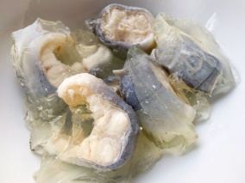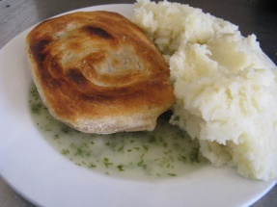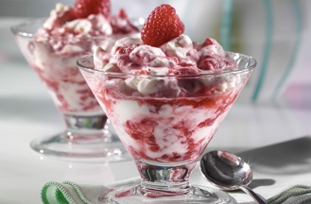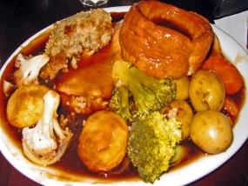
- Make edible oysters.
- Use icing to stick rich Tea biscuits together at an angle (patience needed)
- Roll a piece of ready to roll white icing into a ball and use icing to stick to inside of the biscuits.
- Use icing pens to ice a face to the outside of the oyster
- EAT AND ENJOY
PUT A PICTURE OF ONE I MADE EARLIER
- Try tasting some REAL oysters

GUYS FARM has a building called THE PIGGERY.
- Make chocolate pigs to eat.

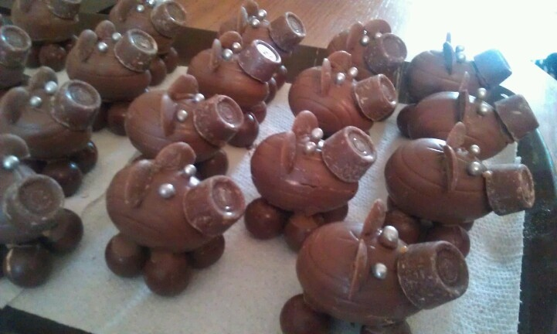
1 crème egg for the body
1 rolo for the nose
1 chocolate button cut in half for the ears
4 maltesers for the feet
2 silver balls for the eyes
1 piece of strawberry lace for the tail
Use melted chocolate to stick together

- Make a chocolate pig cake and have a tea party

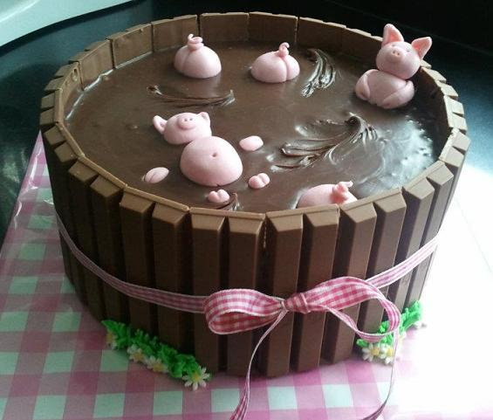

- Make rice crispie apples
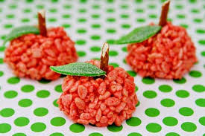
INGREDIENTS

- White chocolate
- Rice crispies
- Red or green food colouring
- Mikado sticks or pretzel sticks
- Mint leaves
- Melt the chocolate
- Add a few drops of food colouring
- Add rice crispies
- Roll a small amount into a ball
- Add a piece of Mikado stick
- Pop on a mint leaf

- Make edible camp fires
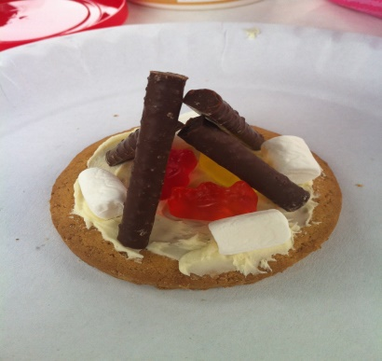
INGREDIENTS
- Digestive biscuit per girl
- Twiglets
- Red and yellow soft sweets (haribo)
- Mini marshmallows
- icing
INGREDIENTS
- 1 orange per girl
- Half a bag of cake mix per girl
- Eggs to suit cake recipe
- Tinfoil
- Cocktail sticks

- Cut the orange in half
- Scoop out the flesh of the orange
- Pour in the made up batter mix
- Attach the lid with cocktail sticks
- Wrap in tinfoil
- Bake in the centre of a campfire or in the oven for approx. 15 mins
- Open and enjoy
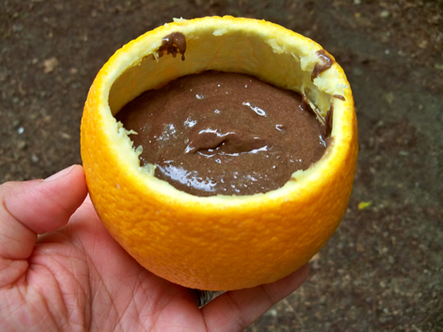
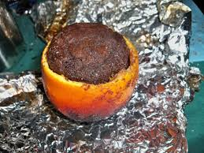
- Make up your own one pot wonder for a campfire
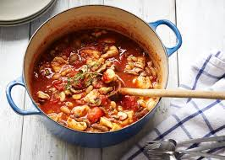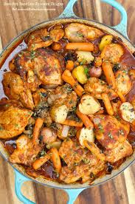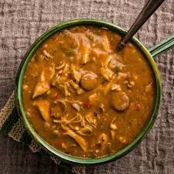
CRAFT TIME

- Make a Pearly King or Queen hat or crown
- Make a Pearly King or Queen outfit (or be a Pearly Princess)
- Create a Mural/Collage to celebrate the 30th Birthday of Guy’s Farm
- Design a flag for the 30th Birthday (send your completed flag to Guys Farm)
- Design and MAKE a flag for the 30th Birthday using scraps of material (send it to Guy’s Farm)
- Design a PEARLY MASCOT
- Design and MAKE a Pearly mascot
- Make a mini Oyster with egg boxes
- 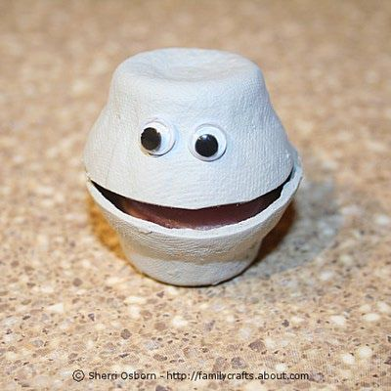 (Fill your oyster with a little pearl (silver ball/salt dough pearl/white chocolate maltesers)
- Make a bowl using buttons
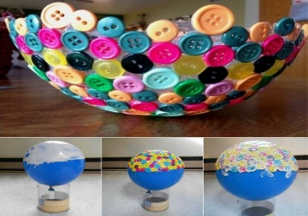
- Make a button tree on canvas
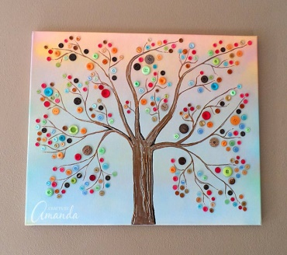
- Make a button Rainbow
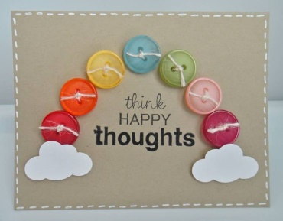
- Make an underwater scene including pearls
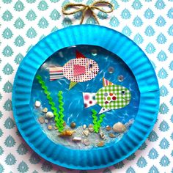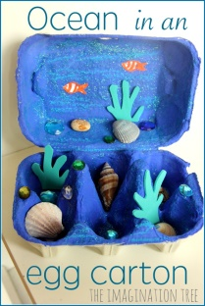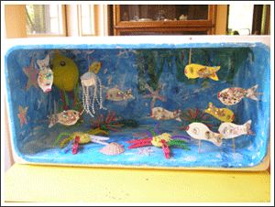
- Colour some underwater pictures
- Draw some underwater pictures
- Write an underwater story about a Pearl
- Make a Birthday Card and send it to Guy’s Farm
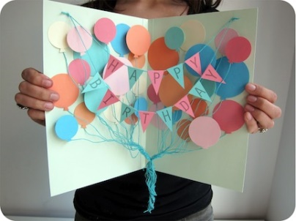
- Create your own craft and share it with other units
- Make pig hats
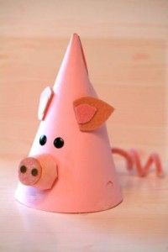
- Use the bottom of a pop bottle to make a pig bowl
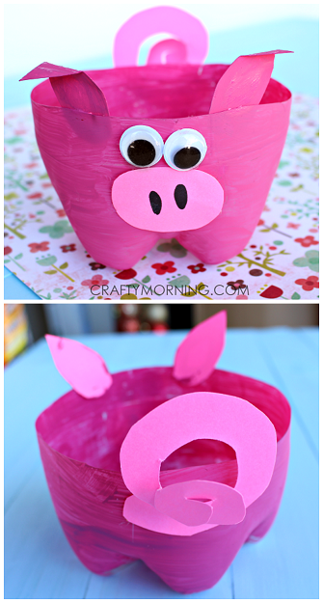
- Make a big apple
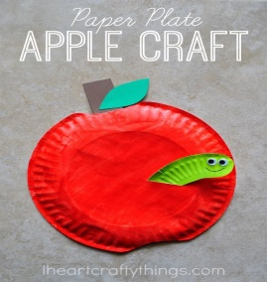
- Make an apple keyring
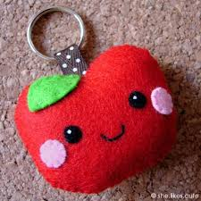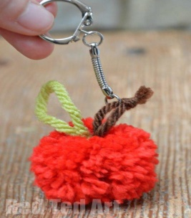

GAMES TIME
- Create a WIDE GAME with a theme (Pearly Kings and Queens, Under the Sea, Pigs in mud)

- FLYING OYSTERS
EQUIPMENT NEEDED
Parachute and 1 ping pong ball per girl (numbered 1 to ---)
- Girls hold the parachute and a leader puts the pearls (ping pong balls) on it.
- After a countdown the girls flap the parachute as hard as they can till the pearls have flown off.
- Each girl then finds 1 pearl.
- The leader shouts out a number, the girl with that pearl wins that round.
- Play again and again and again.

,
- PIGS IN THE MUD

- One girl is chosen to be the WOLF
- The rest of the girls are pigs
- The wolf chases the pigs, when a pig is caught they must stand still with their arms out and their legs open till another pig crawls through her legs and releases her.
- Change your wolf after a few minutes

- LADDERS

Use an under the sea theme to play this popular game.
PEARLS, OYSTERS, DOLPHINS, WHALES, MERMAIDS, STARFISH, CRABS, CLOWN FISH, OCTOPUS AND SHARKS

- PEARL COLLECTING

Just like Human Hungry Hippos, only the balls are pearls and the girls are pearl divers. Whichever team has the most pearls are the winners.
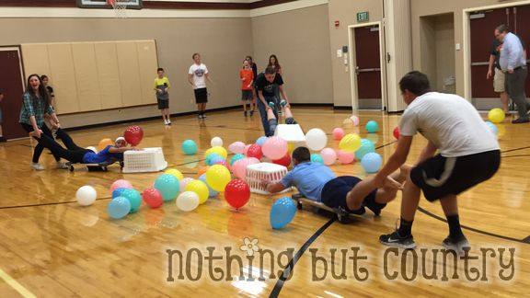

- PINCH THE PEARL

- Divide the GIRLS into two lines of players facing each other.
- Number each player in each line - for example one side are numbers #1-15 (or whatever number you need) left to right and the other line are numbers #1-15 right to left
- Place one ball in between the lines in the middle
- The leader explains that he / she will call the first number from 1-15 and those two players must race to the ball, the first one to get it wins a point for their team.

30
- Collect 30 buttons to take to the Guy’s Farm Birthday celebration.
- Go to the park and collect 30 natural items.
- EXERCISE TIME
DO 30
- Star jumps
- Skips
- Hula hoops
- Hops
- Jumps in the air
- Jumps along the floor
- Laps of the meeting hall
- Sit ups
- Fairy steps
- Steps backwards
- Side steps
- Bottom shuffles

EAT 30
- Eat 30 different foods in one night

SING 30
- Sing 30 different songs

COLLECT 30
- Collect 30 natural objects from the park, around your meeting place or in the country
- Collect 30 buttons to take the Guy’s Farm birthday party

FIND 30
- Can you find 30 or more words from the phrase
“GUY’S FARM PEARL ANNIVERSARY CELEBRATIONS”

TAKE 30
- TAKE 30 PHOTOS: i.e.
- A friend in your palm
- Hug a tree
- Selfie
- Leader and you selfie
- An insect
- An animal
- A flower
- Friendship circle
- A girl making her promise

MAKE IT
- Make a 30 second or 3 minute promotional video for Guy’s Farm (send it to Guy’s Farm)

LEARN 30
- Learn 30 rhyming slang words (just like the Pearly Kings and Queens
JUMP
- Jump in 30 puddles

DRAW 30
- Animals or birds or sea creatures or flowers or trees

How many words can you find in?
“GUY’S FARM PEARL ANNIVERSARY CELEBRATIONS”

OUT AND ABOUT TIME
- Hold a Pearly Pack Holiday

- Hold a Pearly camp

- Visit Guy’s Farm for a cook out

- Visit Guy’s Farm for a picnic

- Complete 30 miles on different forms of transport

- Walk 30KM

- Hold a campfire and sing 30 songs

- Hold a Pearly sleepover

- Walk to Guy’s Farm form Scorton and have a picnic

- DID YOU KNOW? Guys Farm offer lots of different activities including:

- Archery pedal cars
- Abseiling gyro cars
- Bouldering orienteering
- Climbing tower pioneering
- Assault course
- *NEW* WATER ACTIVITIES COMING SOON.
FUN TIME
- Hold a film night, watch under the sea films or Mary Poppins

- Watch the Pearly Kings and Queens’s dance. Make up your own dances
https://youtu.be/GHPbdkMMnZ4 https://youtu.be/bdSvLV-EgSA

- Attend the 30th Birthday celebrations at Guy’s Farm

- Have a game of UNDER THE SEA BINGO

- Have a go at apple bobbing

PEARLY KINGS AND QUEENS
Pearly kings and Queens are an iconic image of London, easily recognised by their distinctive suits and accessories covered with patterns of mother-of-pearl buttons. They've inspired fashion designers, costume makers, and been featured in everything from films to the London Olympics opening ceremony. But do you know the meaning and surprising history behind the costume?
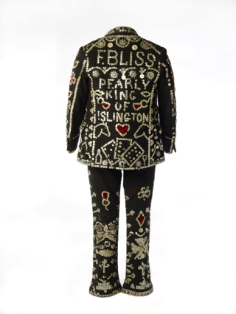

Pearly King suit ensemble
Worn by Fred Bliss, Pearly King of Islington; ID no. 63.7

1. The Pearly tradition was started by a Victorian street-sweeper
The very first Pearly King is accepted to have been Henry Croft, an orphan and street sweeper. In the mid- to late 1870s Croft completely covered his suit in mother-of-pearl buttons, creating the first pearly ‘smother’ suit. He did this to draw attention to himself when collecting money for orphanages and hospitals and so the pearly mission to support charitable organisations was born.
Following Henry Croft's example, Pearlies sew buttons onto their own garments. Buttons are sewn into patterns, words and symbols, which often have specific meanings. A heart means charity and a wheel is the circle of life. On display in the museum is the suit of the Pearly King of Islington, Fred Bliss, which features playing cards on the jacket illustrating that life is a gamble. It also has donkeys, vital in pulling the costermonger’s cart to market.

2. ...but Pearlies have been around even longer
Costermongers were market and street traders who sold fruit, vegetables, fish and other produce from a cart or stall in the street. They were said to have sewn mother-of-pearl buttons on to their clothes to distinguish themselves; a line down outside seam of their trouser legs from knee to ankle as well as on the flaps of their jacket pockets. It was a tradition for each coster community in London to elect a leader, or ‘King’ to organize them, keep the peace and stand up for their rights with authorities. Henry possibly drew on this tradition when he used the term ‘Pearly King’.
There is some debate as to whether Henry was inspired by the dress of London’s costermongers or the costumes of music hall coster-singers. Coster-singers entertained the crowds with cockney songs in the music halls. One singer, Hyram Travers performed around this time as the ‘Pearly King’ and wore ‘the handsomest and most costly suit of clothes ever seen’ (The Era, 20 Jan 1883). Perhaps Henry’s pearly suit was influenced by both groups. It was the costers, however, who embraced the style and ideology of Pearly Kings and Queens.

3. Pearly families are dedicated to charity
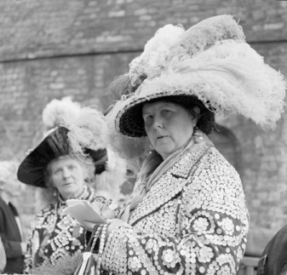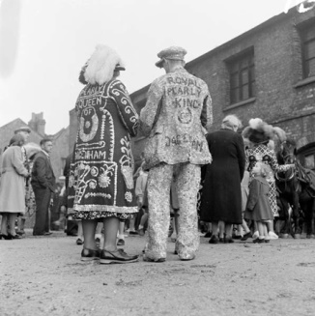
Pearlies are easily recognised by their colourful and eye-catching costumes. We're displaying several extraordinary items in Pearly Treasures, including a magnificent hat decorated with ostrich feathers.
But being a pearly is not just about wearing the costume, it is about a lifelong commitment to work tirelessly to raise money for charity. These days the Pearlies have divided into several organisations; however all still have charity work at their heart.
Henry is also said to have been inspired towards charitable work by the ethos of the costermongers, known as a tight-knit group who watched out for each other.
Henry Mayhew, in his 1851 investigative work London Labour and the London Poor, states ‘I heard on all hands that the costers never steal from one another, and never wink at anyone stealing from a neighbouring stall.’ They would also support fellow costers in distress by holding raffles where the proceeds would be given to the one in need.

4. Pearly titles are hereditary

Just like somewhat grander royal titles, traditionally Pearly titles are passed down through families. Children would be raised in their family’s Pearly traditions and eventually be ‘crowned’ with their parents’ title. On occasion the title would pass to a cousin or other relative. Today some of the old Pearly families have moved out of London so some titles rest vacant. On certain occasions, individuals with a strong proven commitment to charity work may be invited to hold a title. In this case they seek permission to borrow a title from a family who is currently resting theirs, thereby keeping the title alive in London.
One object in the display is a wonderful physical representation of this tradition, a Pearly “princess” dress, made to be worn by a young girl who was the daughter of Pearly parents. The remains of the words “Little Queenie”, sewn in mother-of-pearl buttons, can just be seen on the skirt.

RHYMING SLANG
Adam and Eve – believe
Apples and pears – stairs
Aunt Joanna – piano
Baked Bean – Queen
Baker’s Dozen – Cousin
Ball and Chalk – Walk
Barnet Fair – hair
Barney Rubble – trouble
Boat Race – face
Bob Hope – soap
Bread and Cheese – sneeze
Bread and Honey – money
Bricks and Mortar – daughter
Bubble Bath – Laugh
China plate – mate (friend)
Cock and Hen – ten
Custard and jelly – telly (television)
Daisy Roots – boots
Darby and Joan – moan
Dinky Doos – shoes
Dog and bone – phone
Dustbin lid – kid
Elephant’s Trunk – drunk
Fireman’s Hose – nose
Hank Marvin – starving
Jam-jar – car
Joanna – piano (pronounced ‘pianna’ in Cockney)
Loaf of Bread – head
Loop the loop – soup
Mince Pies – eyes
Plates of meat – feet
Pony and Trap – crap
Rosy Lee – tea (drink)
Ruby Murray – curry
Sausage Roll – goal
Sky Rocket – pocket
Tables and chairs – stairs
Tea leaf – thief
Todd Sloane – alone

