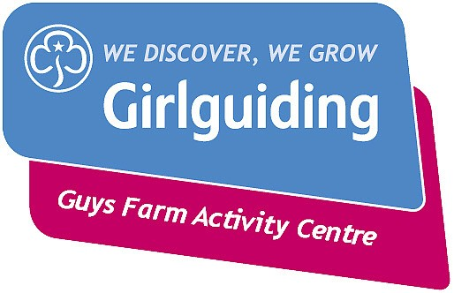
Friends of Guys Farm invite you to a Guide Badge Day

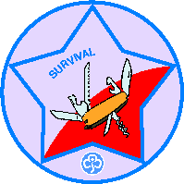
28 April 2018 at Guys Farm Activity Centre Arrive 9.30 for 10am start. The event will finish at 4pm
Cost: £10 per Guide.

A chance for Guides to gain their Survival badge whilst having loads of fun at Guys Farm!
Survival Badge
1. Make an emergency shelter and explain what needs to be considered when selecting a site for it.
2. Demonstrate one way of collecting water.
3. Pack a bag for a day trip to an area unknown to you. This may be an urban or rural location.
4. Describe early signs of extreme weather conditions.
5. Choose two activities from the following list and demonstrate them:
• Show one way of finding north without using a compass.
• Light a fire and cook a two-course meal without utensils.
• Recognise three edible and three non-edible plants (you may use pictures). Explain how you could use the edible plants in a menu.
• Prepare an emergency survival kit either for an urban area or for a rural area. Explain why you have chosen each item.
6. Know how to use a street map and plan a route to a given location.
7. Find out about your local transport system, including the times of the last train, bus, Tube or coach to your home

Mm

mmfmfmfmmfmfm

mvmvmvmvmmfjjfrjfnfnbfbfbgvb

Guide Badge Day 28 April 2018

Guide Name………………………………………………………………………………..
Address…………………………………………………………………………………………
…………………………………………………………………………………………………….
Parent/Carer Name………………………………………………………………..…..
Guide Unit……………………………………………………………………………..…….

Please return the completed form, with the payment of £10, to your Unit Leader before 23rd March 2018.
Cheques should be made payable to ‘Friends of Guys Farm Activity Centre’
_____________

Guides should wear their uniform and, as the activities will take place outside in a field, suitable footwear and outer wear.
To complete the badge you will need to bring with you - a/ a small amount of kindling wood b/ a bag packed for a day trip to an area unknown to you. This may be an urban or rural location.
Please bring a refillable plastic drinks bottle.
You will be cooking lunch, please tick which you would like
Fish finger butty Pizza

If you have any food allergies please give details here ……………………………………………………………………………………………………………………………..

