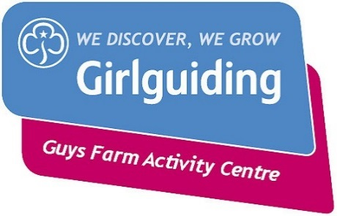
Guide Badge Day
28 April 2018

Dear Leaders
Friends of Guys Farm are organising a badge day for Guides next April, the aim is to give the girls a fun day whilst gaining their Survival badge, it will also give girls and leaders who have never been to Guys before the opportunity to visit our fantastic activity centre and also raise revenue for the site.
We would really appreciate your help to promote the event in your unit by encouraging your Guides to attend.
The cost is £10 per Guide which includes a badge and lunch but does not include transport. You may be able to arrange transport in your area if other local units are attending, if not parents should be encouraged to car share.
The flyer explains what girls need to bring with them - the bag is one of the clauses of the syllabus and the kindling is for cooking their lunch.
Leaders should bring a packed lunch, but tea and coffee will be provided (please bring an insulated travel mug).
The shop will be open in the afternoon and therefore girls may like to bring spending money.
Please note that the closing date for applications for the girls is 23rd March 2018, applications and payment must reach Friends of Guys Farm by 31st March 2018. Please send to Friends of Guys Farm Activity Centre, c/o 44 Golden Hill Lane, Leyland PR25 3NP. Cheques should be made payable to ‘Friends of Guys Farm Activity Centre’
Please provide an email or postal address for your unit where further information and a I day activity form will be sent when your application has been received.
Best wishes

Sylvia Fisher Chairman, Friends of Guys Farm email; friendsofguysfarm@hotmail.com tel.no; 07711 573091

